**The Effect of Tofu as a Protein Replacer for Egg in Pound Cake**

**Carolyn Trueblood, Heather Kristofzski, Jenna Runchey, Victoria Mullen**

**NUTR 453**

**November 30, 2015**

**Abstract:**

Tofu has been known for its effects on lowering the risk of chronic disease, unlike its protein counterparts of meats and eggs, which are linked to raising the risk of various chronic diseases. The experiment conducted tested whether replacing the egg in a common pound cake with two different types of tofu were adequate in regards to texture, appearance, more particularly color, and consumer preference while making the cake overall healthier by reducing the amount of saturated fat and cholesterol. It was hypothesized that replacing the egg in the pound cake with soft or firm/hard tofu would in fact not affect the texture, appearance, or consumer preference. It is important for the samples with the various types of tofu to have the same desirability to the consumer as the control. This was tested by a hedonic preference scale, which was distributed to 21 panelists for the three trials that were conducted. The control was preferred overall, however, in the last two trials the texture analyzer proved that the overall texture of the cake with the hard/firm tofu and the control were almost identical. There was no significant change in the color among the variations of tofu compared to the control among the three trials.

**Introduction:**

The Dietary Guidelines for Americans is the cornerstone of federal nutrition policy and education in the United States. Issued every five years by the Department of Agriculture and Department of Health and Human Services, these guidelines provide advice for healthy eating patterns in order to achieve and maintain a healthy weight, reduce the risk of chronic disease, and promote an overall healthier lifestyle. Current staples of a Western diet include red meat, dairy, and many saturated fats. However, the Dietary Guidelines for Americans 2010 suggests a diet low in red meat and saturated fats and high in fruits, vegetables, and whole grains (Dietary Guidelines for Americans, 2010). With an obesity rate of 34.9% in 2012, and increasingly high numbers of deaths linked to obesity, hypertension, and diabetes, it is clear that the general population is not using these guidelines. The aim of this experiment is to take a common dessert and replace an ingredient, egg, which is linked to issues of hypertension, with tofu, an ingredient linked to decreased risk for chronic disease, test ease of preparation and appeal to the consumer.

According to the Public Health Nutrition Journal, in a study of 98 young, Dutch females, replacement of meat and dairy foods with plant-based foods reduced land use for consumption and did not compromise their iron intake (Temme, 2013). This is just one of many reasons switching from meat and dairy to more plant-based foods can improve health, help the environment, and save lives. According to Nutrition & Food Science, fortified vegan dairy replacers have just as much, if not more, nutrients than regular dairy options, and do not pose as great of a risk for things such as obesity and cardiovascular disease with which meat and dairy products are associated (Lightowler, 1998). Also, according to the Island Press, to feed and water farm animals takes enormous amounts of water. To produce just one pound of meat requires on average 2,500 gallons of water and a gallon of cow's milk requires 750 gallons of water. By switching to a vegan diet, one can save 1.3 million of gallons of water a year. On top of that, clearing trees to create fields for grazing and feed crops for farmed animals are the primary contributing factors in land degradation and the loss of plant and animal species. Lastly, switching from meat and dairy to plant-based foods saves countless animals’ lives.

These are just a few of the reasons for this experiment, in which tofu was used as a protein replacer for the egg in pound cake. It was hypothesized that switching an ingredient in pound cake such as egg, which is packed with 1.6 grams of saturated fat and 187 milligrams of cholesterol per serving, to an equal portion of tofu, which carries only 0.18 grams saturated fat and 0 milligrams of cholesterol, can improve the quality of the food with no significant effect on texture, color, or appeal of the product. In order to test this hypothesis, a texture analyzer was used to evaluate texture and a colorimeter was used to evaluate the color of the cake. Subjectively, a consumer preference 9-point hedonic rating scale was employed to evaluate if there was any difference in preference of cake made with egg compared to cake made with tofu.

Tofu and egg were both used as a source of protein this experiment. One egg (about 50 grams) contains about 6g of protein, while an equal amount of tofu contains approximately 3.57g of protein. This is a significant loss of protein for nutritional benefit; however, the purpose of protein in this recipe is not for protein nutritional benefit, but rather for emulsifying and thickening properties. Egg is used in pound cake because it provides protein which participate in emulsion creation as well as stabilization of the newly formed emulsion. The emulsifying capacity is the ability of the protein to emulsify oil. Proteins have been shown to stabilize emulsions by forming a viscoelastic layer around the oil droplets, which provides a barrier for re-conjugation of the droplets and allows for a small droplet size distribution and low interfacial tension (Wilde, P., 2004). It had been predicted that tofu would sufficiently replace the egg as an emulsifier, while also providing the benefits of lowered saturated fat and cholesterol, and having no significant effect on texture, color, or appeal of the final product.

Three variables were presented in this experiment, being texture, color, and overall appeal, which were dependent on the variable of protein source. To test the effect on these variables, three test were run, each in which three cakes were made: one with soft tofu, one with extra firm tofu, and one with egg as a control. After baking, color was measured with a Hunter colorimeter. which provides a direct measure of color and appearance. It does this by reporting L, a, and b values of white/black, green/red, and yellow/blue, respectively, which are the basic complimentary colors perceived by the human eye. A representation of the Hunter notation can be seen below in Figure 1.

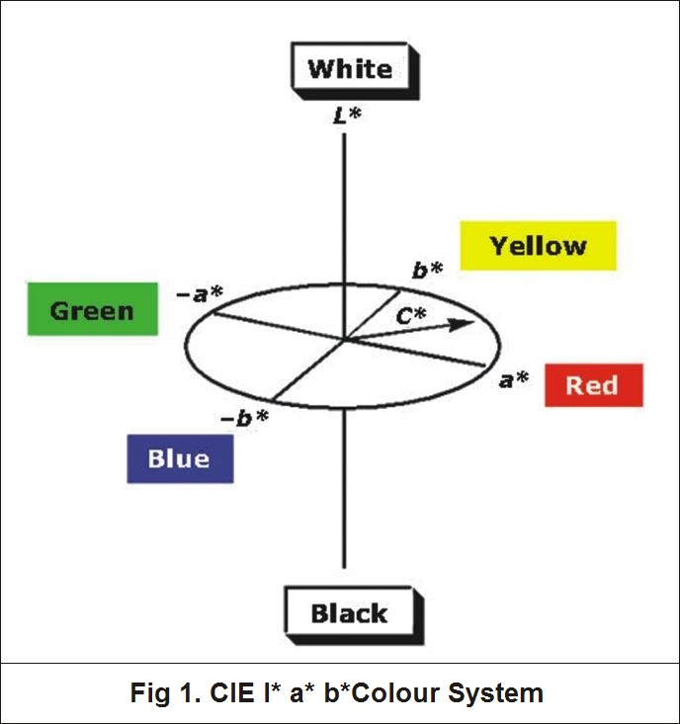

Figure 1. This is a diagram of Hunter notation, used by a colorimeter to characterize the product by giving numerical significance to the color wheel, and providing a scale between complementary colors, by which each color is evaluated.

A Brookfield texture analyzer was used to evaluate hardness of the product by measuring force needed to attain deformation of the cake, which was then represented by a numerical value obtained from a plot of force. This value was provided as the final peak of the texture profile analysis curve. An example of a graph generated from a texture analyzer can be seen below in Figure 2.

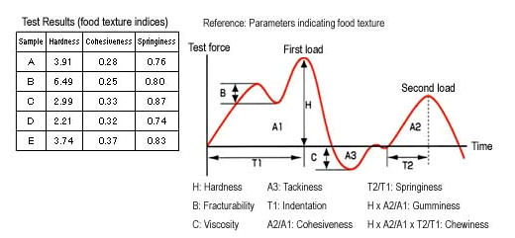

Figure 2. This image is an example of the graph given by the texture analyzer, which was used to evaluate hardness of the final product.

To measure consumer preference of each cake, a 9-point hedonic rating scale was used, which allowed a board of tasters to rate overall preference of each cake. Results of the consumer preference were then statistically analyzed for significance and conclusions on whether tofu is a viable replacement for egg in pound cake were drawn.

**Methods:**

In order to test whether the hypothesis was true, a test of protein variables was carried out three times. A total of nine- pound cakes were made; three of each protein variable, which included egg, soft tofu and extra firm tofu. After each cake was made, three tests were carried out on each cake to measure texture, color, and overall consumer preference. A texture analyzer and colorimeter were used to objectively measure texture and color, respectively. The probe used for the texture analyzer was a flat probe called the slice 50nm. A nine-point hedonic preference scale was used to subjectively measure consumer preference.

Materials

218.75 grams all-purpose flour

3.45 grams baking powder

1.5 grams salt

170.25 cups butter at room temperature

150 grams sugar

44.42 mL milk

189 grams tofu (Variable 2- soft tofu, Variable 3- extra firm tofu)

7.16 mL vanilla extract

3 eggs (This is only for Variable 1-Control, do not add tofu to Variables 2 or 3)

In order to minimize error and have controlled variables, all of these ingredients were kept at room temperature, other than those, which needed to be refrigerated. For those ingredients that needed to be refrigerated, we kept them refrigerated at all times, and only removed them when in use, and they were promptly returned to the refrigerator.

**Procedure:**

1. Preheat the oven to 350F/180C and grease and flour a 9x5 inch (22.86cm x 12.7cm) loaf pan. 2. Sift the flour, baking powder, and salt into a bowl and set this aside.

3. Use a hand mixer to mix the butter and sugar for one minute at a medium speed.

4. Add 2 % milk and vanilla to the butter and sugar mixture and beat well. The tofu will then be added, but not beaten, just mixed with a wooden spoon.

5. Add the flour mixture slowly, mixing with the hand mixer on a low speed until blended.

6. Spread the batter in the loaf pan and bake for 60 minutes and let cool.

7. Use the texture analyzer to measure firmness and colorimeter to measure color.

8. For subjective measurement, have panelists complete a consumer preference hedonic scale.

Each cake was assigned a random 3-digit number; 124-egg, 938- soft tofu, and 754- hard tofu. Each of 21 total panelist was given a piece of cake to try without knowing what was in each variable and told to score them according to their preference based on color, taste, and mouth-feel. Each panelist marked only one of nine options for each variable, based on how much they liked the cake. Then, the results were put on a scale from 1 to 9,1 being dislike extremely, and 9 being like extremely. The results were the compounded and compared between variables.

**Sensory Evaluation**

Please mark your preference for each of the samples.

**124**

____ Like extremely

____ Like very much

____ Like moderately

____ Like slightly

____ Neither like nor dislike

____ Dislike slightly

____ Dislike moderately

____ Dislike very much

____ Dislike extremely

**938**

____ Like extremely

____ Like very much

____ Like moderately

____ Like slightly

____ Neither like nor dislike

____ Dislike slightly

____ Dislike moderately

____ Dislike very much

____ Dislike extremely

**754**

____ Like extremely

____ Like very much

____ Like moderately

____ Like slightly

____ Neither like nor dislike

____ Dislike slightly

____ Dislike moderately

____ Dislike very much

____ Dislike extremely

**Discussion:**

Overall, the null hypothesis was proven false. Tofu does not serve as a viable replacement for egg in pound cake based on texture and overall consumer preference, in these conditions. A board of 21 panelists measured the overall preference for each cake for all three trials. They each rated their overall preference of each cake based on a 9-point hedonic scale of liking to the cake. It can be seen in Figure 3 that consumers preferred the egg in the cake more than either soft or hard tofu being used. When using tofu, consumers preferred the soft over the extra firm tofu, based on color, taste, and mouth-feel.

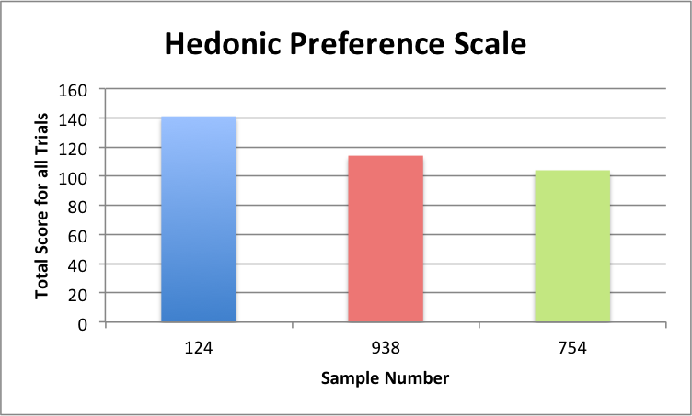

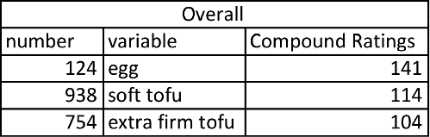Figure 3: Hedonic Preference Scale. Shows how the 21 panelists across the three trials rated their preference for each cake. A number was assigned to each preference option and then totaled for each protein variation among all three trials. The table shows the overall results.

Based on the table of texture analysis, one can see that when egg is used as an emulsifier in pound cake, the firmest cake is produced, but is closely matched in texture when extra firm tofu is used. However, when soft tofu is used, it takes significantly less force to deform the cake, and is therefore not as firm as when egg is used as shown in Figure 4. The first trial is a little skewed when it came to the likeness in the egg and firm/hard tofu due to the fact that the samples didn’t bake thoroughly which was corrected in the next two trials that were performed.

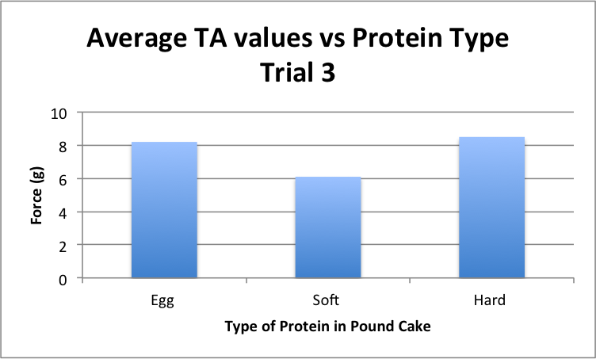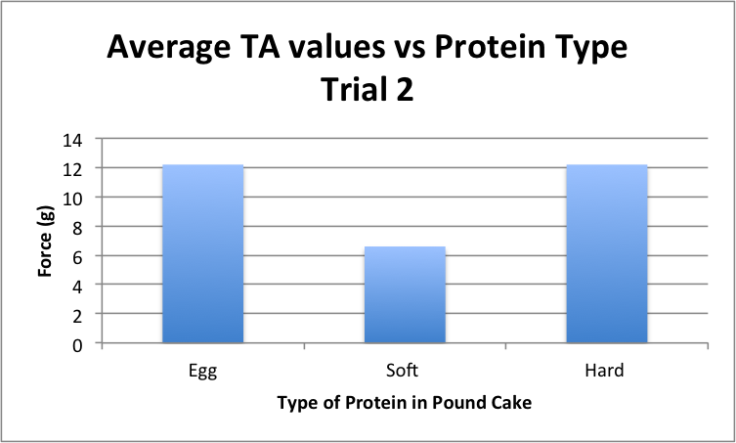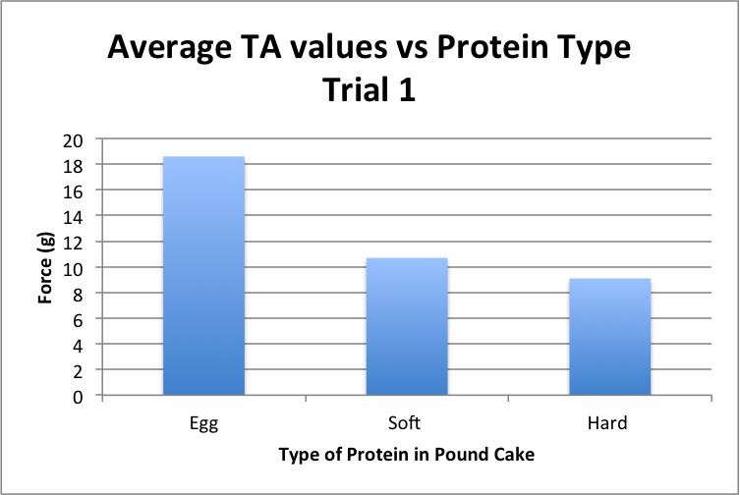

Figure 4: Shows the difference in textural analysis, among the three different protein types; eggs, soft tofu, and hard tofu, and among the three different trials conducted.

Color of each product was measured after baking by a Hunter colorimeter, which bases color values on a 3 point axis of L: which lightness (white to black), a: which is red to green, and b: which is yellow to blue. From these results, one can see that color varied significantly from one trial to the next, for all variables as shown in Figure 5. There is no outstanding pattern of one variable being lighter or darker, or more yellow or green, etc. From this, it was concluded that using tofu as a replacer for egg in pound cake had no significant effect on color of the final product. According to <http://statistica.mooo.com/> we found that the p-values for the texture analyzer and colorimeter were insignificant.

Figure 5: Shows the difference in the values for the Hunter colorimeter among the three different protein types; eggs, soft tofu, and hard tofu, and among the three different trials conducted. 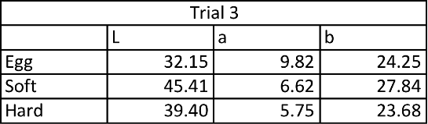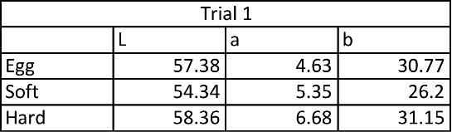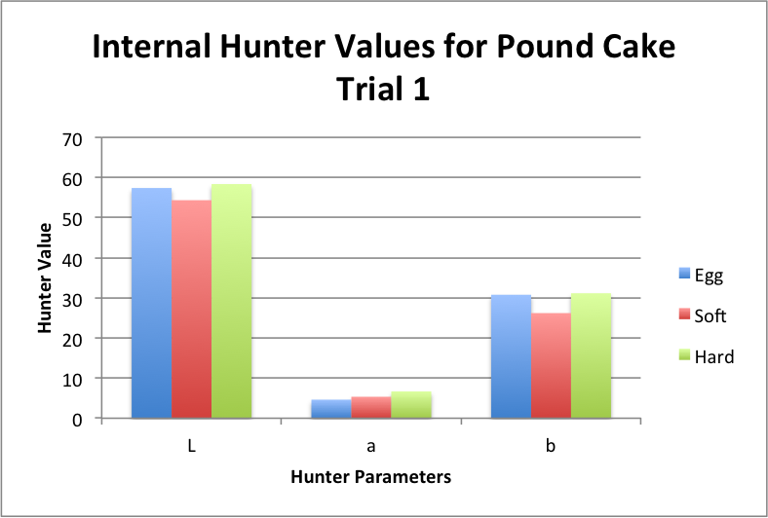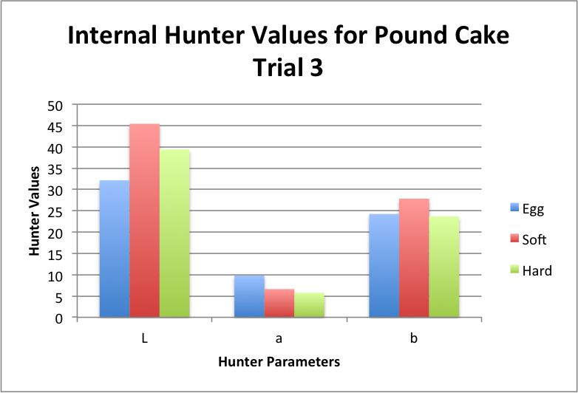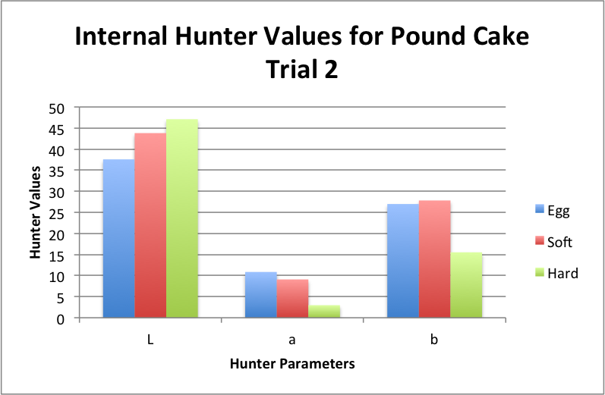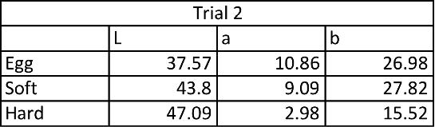

For each variable, the middle of each cake was used to measure texture and color. It was kept consistent throughout each test; however, it may have made a difference on both texture and color if the edges or the top of the cake was used instead. The panelists were not only given pieces from the center to observe and taste because there was not enough pieces from the center for all tests. This may skew results because some panelists may prefer a center piece, while others prefer an edge, In future experiments, one could objectively measure the remaining pieces of the cake and analyze whether that makes a difference on texture and color. Also, each panelists should be given a piece of cake from the same area, and it should be kept consistent throughout each trial. A future project could involve another way to replace the egg and see if the consumer prefers it more than the tofu replacer. A possible way to do that would is by replacing ¼ cup of applesauce mixed with ½ tsp baking powder in for each egg that is required by the recipe. Another source of error in this experiment stems from baking time. Each cake was supposed to have been baked for 60 minutes. However, in the first trial, all cakes were taken out after 54 minutes because a toothpick was inserted into the center and came out clean. However, the cakes turned out not to be done all the way and were very soft and gooey in the very center, especially the soft tofu variable. For the next two trials, cakes were again taken out at 55 minutes, and again we still gooey on the inside. In future experimentation, all cakes should be baked for a minimum of 60 minutes, in order to ensure doneness. This may have led to inaccurate results of preference because if each cake had been done all the way it may have affected the panelists liking towards each cake.

In conclusion the experiment showed that there was a difference in consumer preference among the control and tofu variations, regardless if the tofu was soft or hard. The null hypothesis was rejected and replacing the egg with tofu does alter the preference and texture in regards to the soft tofu.

**Results:**

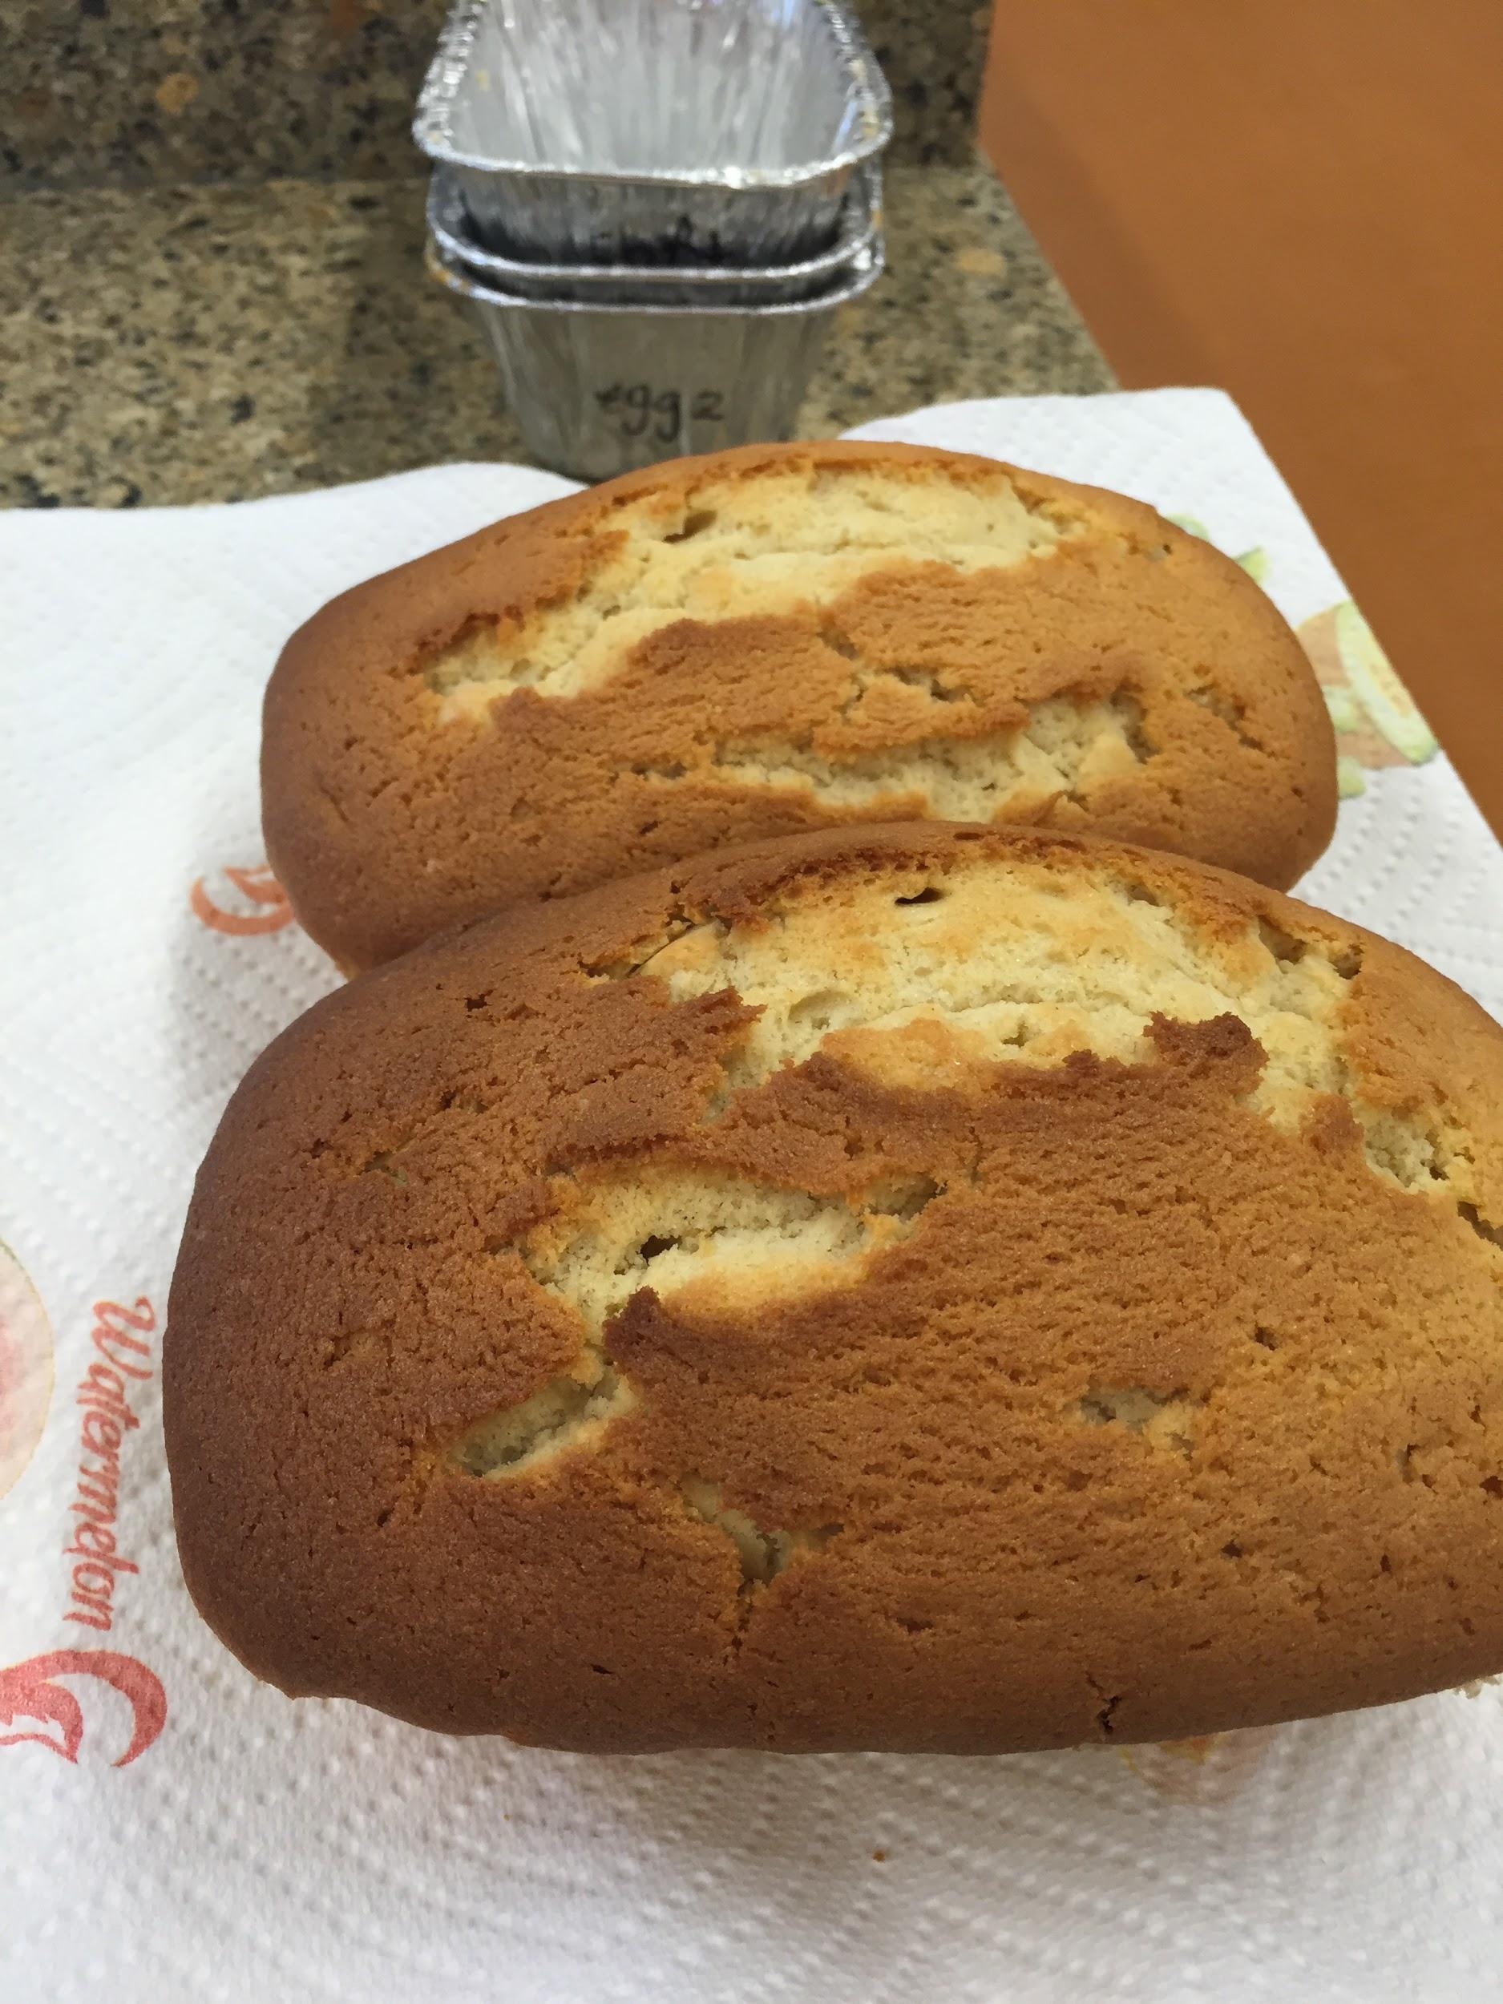

*Photo 1. Pound cake made with egg.*

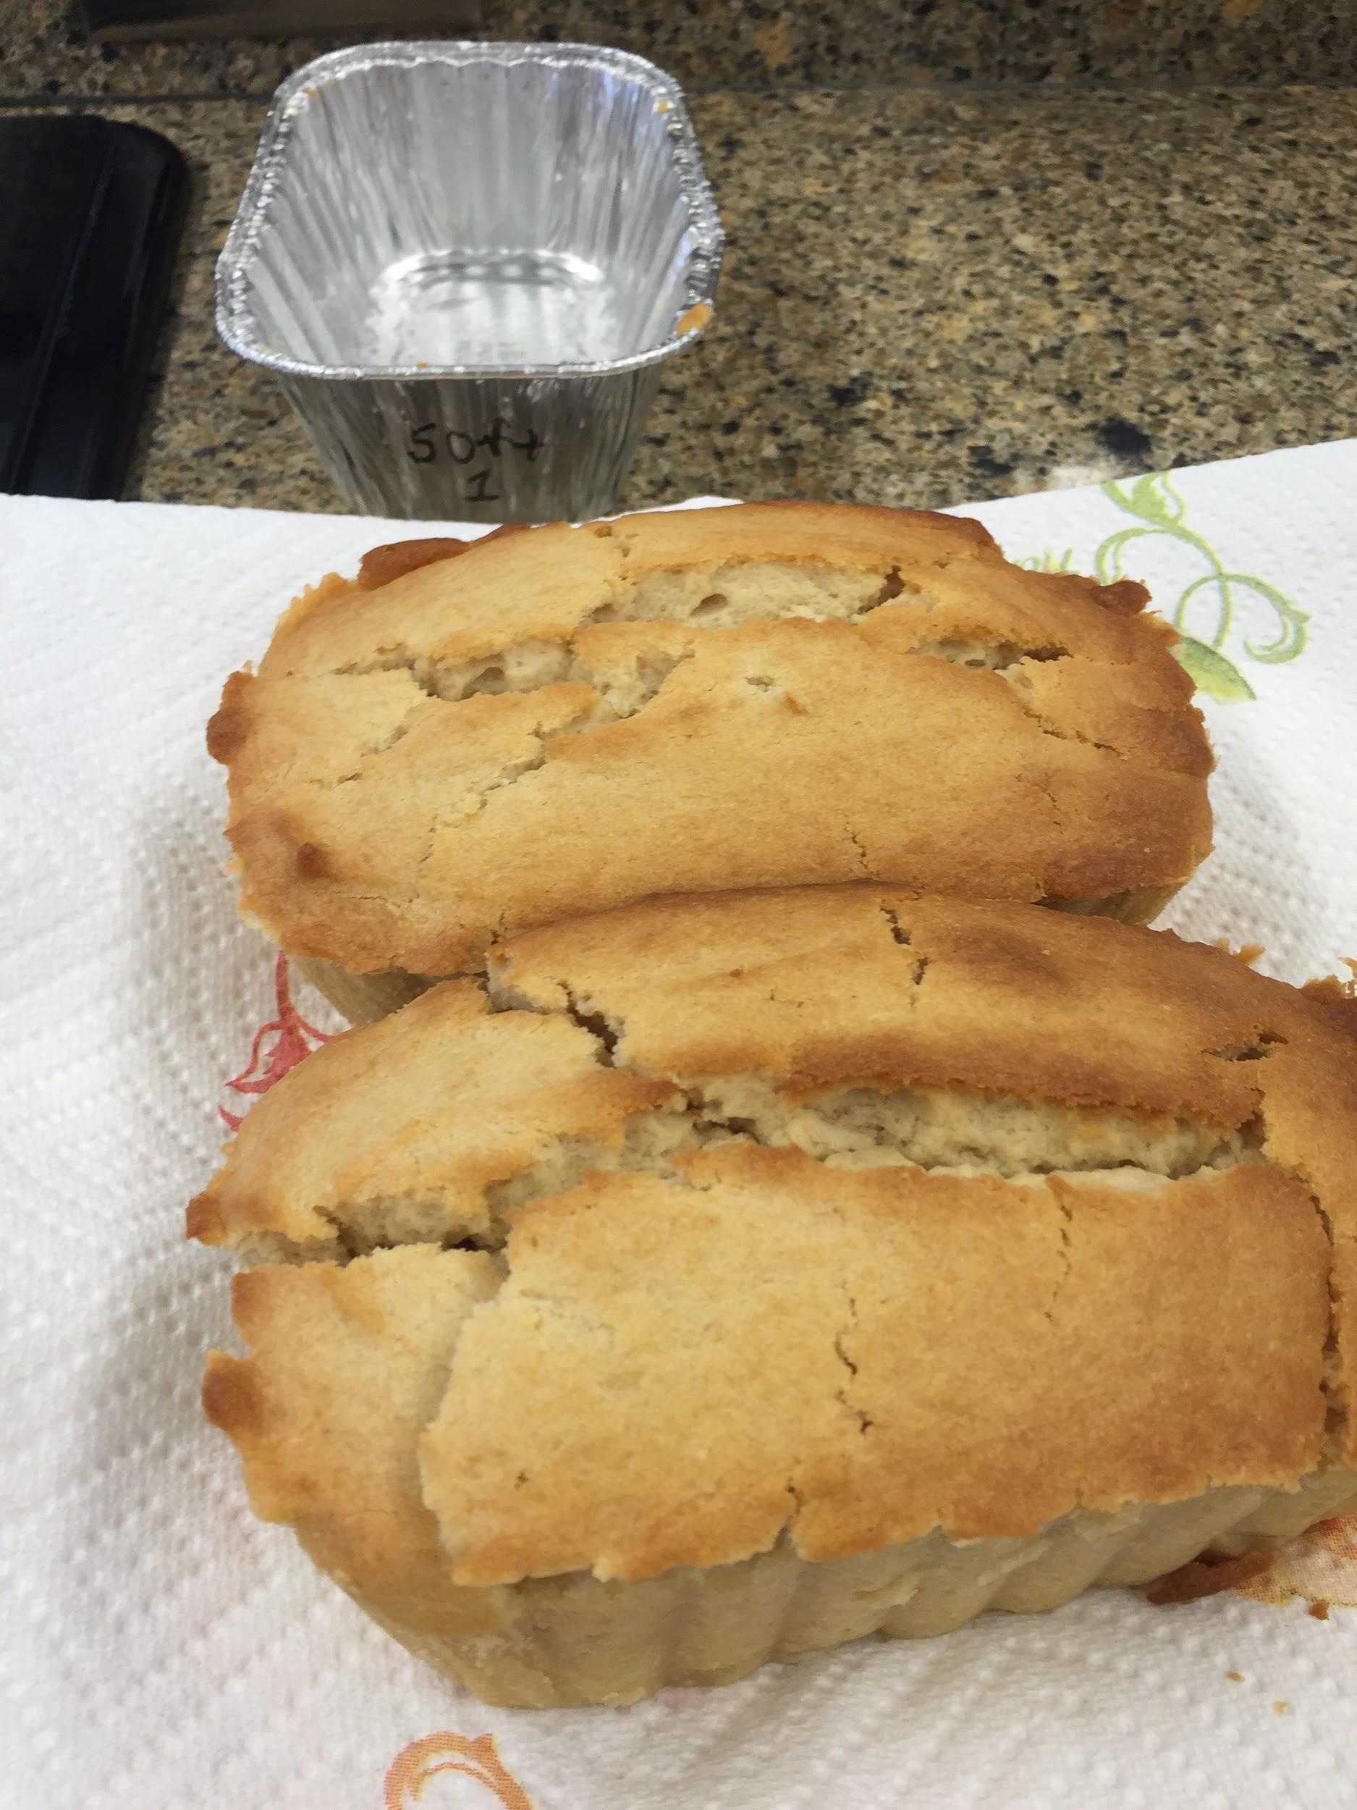

*Photo 2. Pound cake made with soft tofu.*

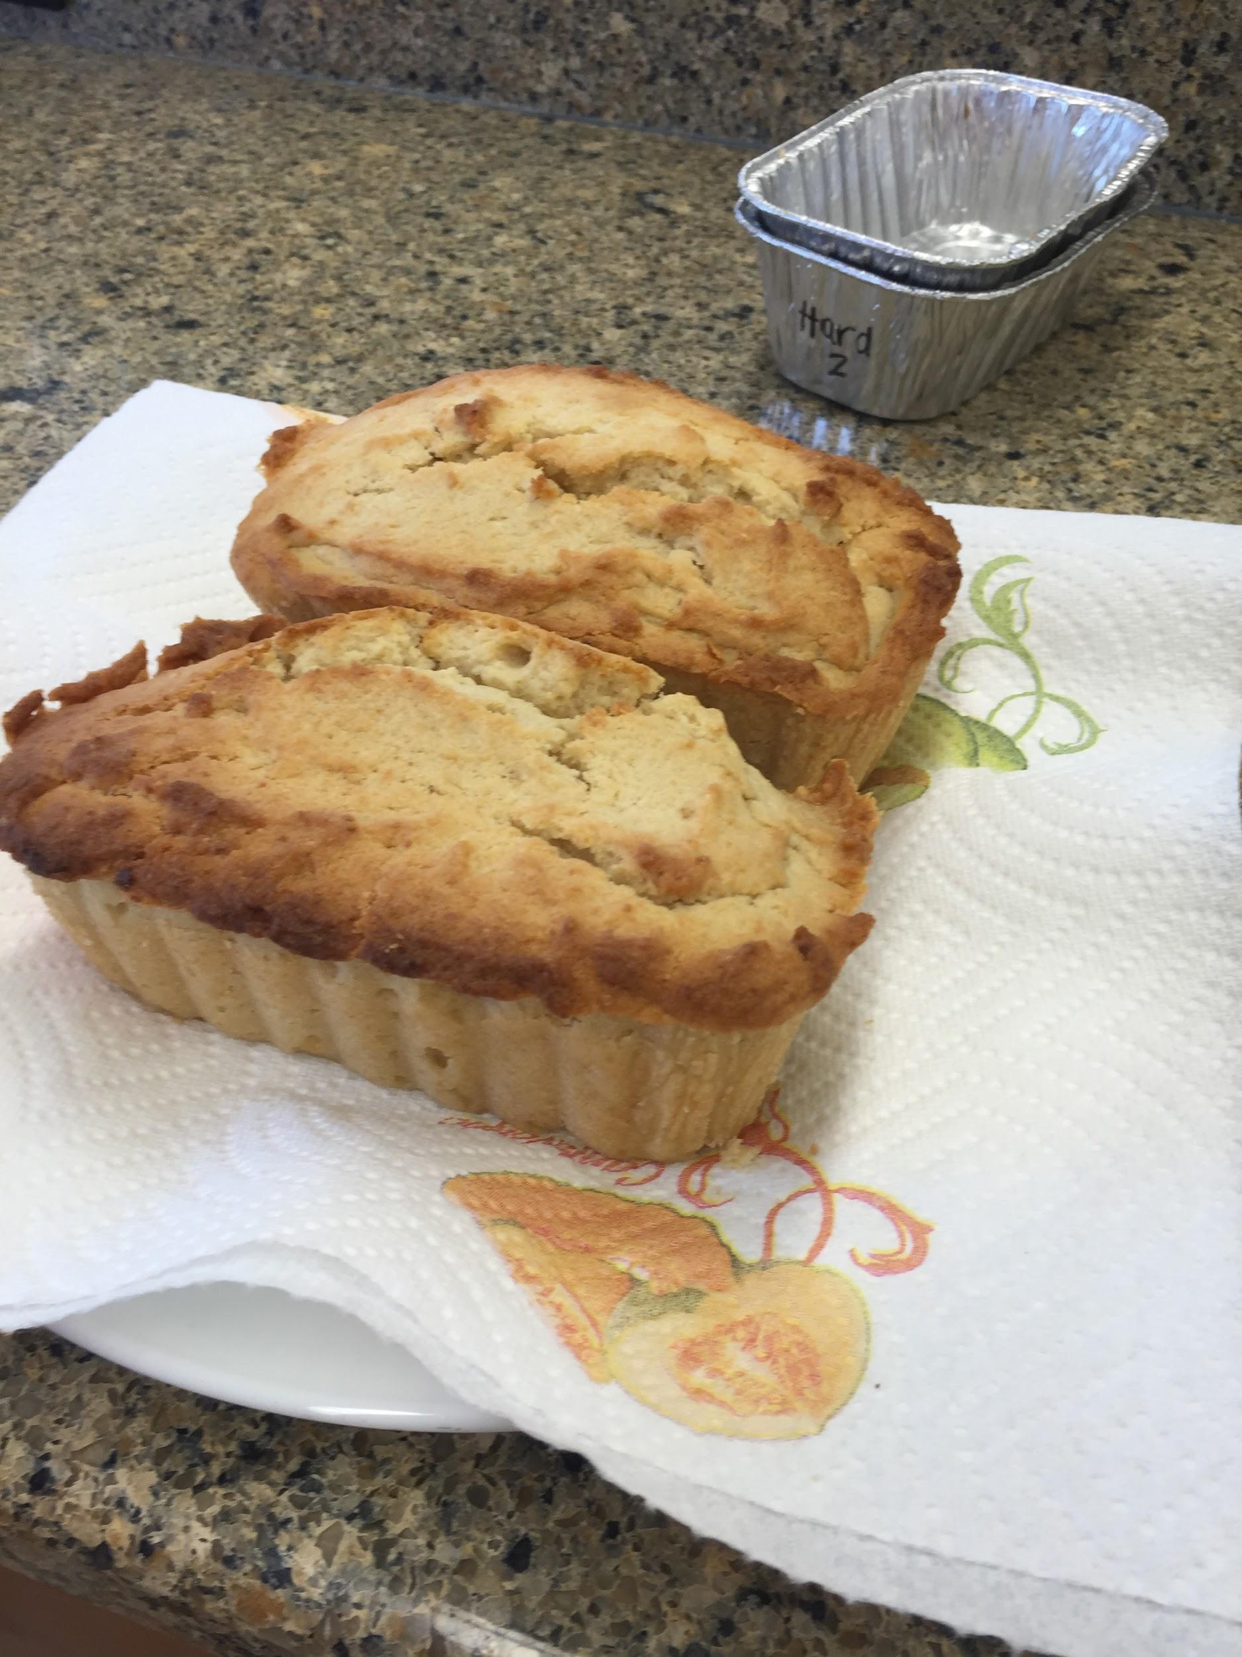

*Photo 3. Pound cake made with hard tofu.*

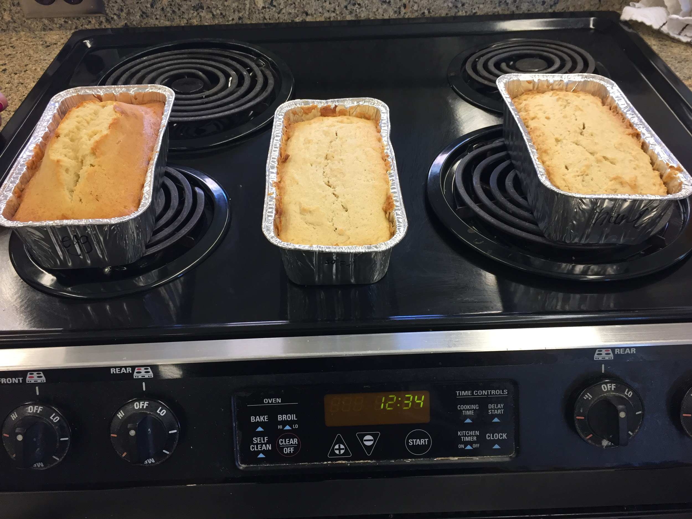

*Photo 4. Each variation compared side by side. (In order from left to right: egg, soft tofu, hard tofu)*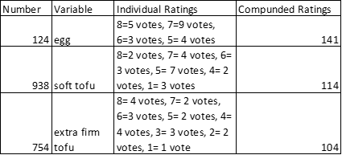

*Table 1.Hedonic Preference Scale: Subjective consumer preference ratings of a board of 21 panelists on each of the three variables of pound cake.*

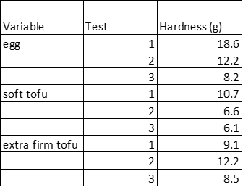

*Table 2. Texture: Evaluation of hardness of each cake by the texture analyzer, based on grams of force needed to deform cake.*

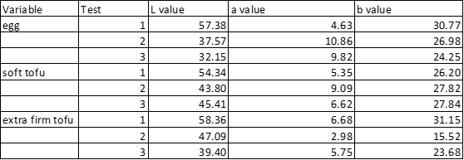

*Table 3.Appearance: L, a, and b values of white/black, red/green, and yellow/blue, respectively measured by a Hunter colorimeter.*

**Statistical Data**

**Data for the Texture Analyzer:**

|  |  |  |  |
| --- | --- | --- | --- |
| ***Turkey HSD Test*** | | | |
| ***Treatment pair comparisons*** | ***q statistic*** | ***p-value*** | ***Inference*** |
| *Egg vs. Soft* | *2.5362* | *0.2494119* | *insignificant* |
| *Soft vs. Hard* | *1.4957* | *0.5709658* | *insignificant* |
| *Egg vs. Hard* | *1.0405* | *0.7406039* | *insignificant* |

|  |  |
| --- | --- |
| **One Way- ANOVA** | |
| ***F statistic*** | ***p-value*** |
| *1.6254* | *0.2728* |

**Data for the the L value:**

|  |  |  |  |
| --- | --- | --- | --- |
| ***Turkey HSD Test*** | | | |
| ***Treatment pair comparisons*** | ***q statistic*** | ***p-value*** | ***Inference*** |
| *Egg vs. Soft* | *0.9504* | *0.7741744* | *insignificant* |
| *Soft vs. Hard* | *1.0255* | *0.7461839* | *insignificant* |
| *Egg vs. Hard* | *0.0751* | *0.8999947* | *insignificant* |

|  |  |
| --- | --- |
| **One Way- ANOVA** | |
| ***F statistic*** | ***p-value*** |
| *0.3268* | *0.7333* |

**Data for the A value:**

|  |  |  |  |
| --- | --- | --- | --- |
| ***Turkey HSD Test*** | | | |
| ***Treatment pair comparisons*** | ***q statistic*** | ***p-value*** | ***Inference*** |
| *Egg vs. Soft* | *1.3140* | *0.6386793* | *insignificant* |
| *Soft vs. Hard* | *1.1589* | *0.6964707* | *insignificant* |
| *Egg vs. Hard* | *0.1551* | *0.8999947* | *insignificant* |

|  |  |
| --- | --- |
| One Way- ANOVA (A value) | |
| ***F statistic*** | ***p-value*** |
| *0.5156* | *0.6214* |

**Data for the B value:**

|  |  |  |  |
| --- | --- | --- | --- |
| ***Turkey HSD Test*** | | | |
| ***Treatment pair comparisons*** | ***q statistic*** | ***p-value*** | ***Inference*** |
| *Egg vs. Soft* | *2.3000* | *0.3059412* | *insignificant* |
| *Soft vs. Hard* | *1.5958* | *0.5336872* | *insignificant* |
| *Egg vs. Hard* | *0.7042* | *0.8659271* | *insignificant* |

|  |  |
| --- | --- |
| One Way- ANOVA (B value) | |
| ***F statistic*** | ***p-value*** |
| *1.3877* | *0.3194* |

**References**

(*Ecological Integrity: Integrating Environment, Conservation and Health* (Island Press, Washington DC, 2001).

[Helen Lightowler](http://www.emeraldinsight.com.ezproxy.lib.purdue.edu/action/doSearch?ContribStored=Lightowler%2C+H), [Jill Davies](http://www.emeraldinsight.com.ezproxy.lib.purdue.edu/action/doSearch?ContribStored=Davies%2C+J), (1998) "The vegan dairy", Nutrition & Food Science, Vol. 98 Iss: 3, pp.153 – 157

Kao, Fuh-Juin, J. Agric. Food Chem. 2003, 51, 6211-6216

Temme, E. (2013). Replacement of meat and dairy by plant-derived foods: Estimated effects on land use, iron and SFA intakes in young Dutch adult females. *Public Health Nutrition,* *16*(10), 1900-1907. Retrieved September 23, 2015

Wilde, P. (2004). Proteins and Emulsifier at Liquid Interfaces. *Advances in Colloid and Interface Science,* *63*(71), 108-109. Retrieved November 24, 2015.